Guía de tallas camiseta carrera 16k Trail Minero santa Bárbara Hunosa 2026

 | 4-5 | 6-8 | 10-12 | 13-14 | XS | S | M | L | XL | 2XL | 3XL | 4XL
A | 35 | 38.5 | 41 | 44 | 46 | 48 | 50 | 54 | 58 | 62 | 64 | 66
B | 49 | 52 | 56 | 62 | 64 | 66 | 68 | 70 | 72 | 74 | 76 | 78

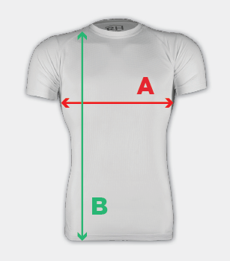

Guía de tallas cortavientos carrera 42k Trail Minero santa Bárbara Hunosa 2026

